Section 4.2 — Impact Mapping: Top 3 Findings
FINDING 1 (Critical) - FLOAT Data Type Used for All Financial Columns
Description
All monetary columns across the LewisRetail database - including UnitPrice, TotalAmount, VATAmount, DiscountAmount, CreditLimit, and CurrentBalance - are declared as FLOAT. The FLOAT data type uses binary floating-point representation and cannot accurately represent many decimal values. For example, R0.70 stored as a FLOAT may internally become R0.70000000000000001. This rounding error accumulates across thousands of order calculations, VAT computations, and credit balance operations.
Financial Impact
Revenue Reporting Error
SUM(TotalAmount) across 5,200 orders using FLOAT arithmetic produces a total that diverges from the mathematically correct sum. Depending on the distribution of values, this error can reach hundreds of rands per reporting period, leading to management decisions based on incorrect revenue figures.
VAT Miscalculation
The pricing engine in server.js (line 1196) calculates VAT as: afterDiscount * (VATPercentage/100.0) using FLOAT. With South African VAT at 15%, rounding errors of R0.01 to R0.05 per transaction are common. Across 5,200 orders this could total R50–R260 in incorrectly calculated VAT, creating a tax liability risk.
Credit Balance Drift
CreditAccounts.CurrentBalance is stored as FLOAT. Credit balance calculations that add or subtract FLOAT values accumulate error over time. Customers could be incorrectly shown as over their credit limit, or allowed to exceed it, depending on the direction of the rounding error.
Revenue Leakage
Combined with the R0.00 TotalAmount defect, the FLOAT imprecision masks the true revenue gap, making audits unreliable. Internal financial controls are undermined because no two calculations of the same figure will necessarily agree.
LEGAL IMPACT
National Credit Act (NCA) - The NCA requires that credit charges be disclosed accurately and calculated correctly. FLOAT-based credit balance and interest calculations violate this requirement. If a customer is overcharged due to rounding errors on their credit account, Lewis Retail Group could face complaints to the National Credit Regulator (NCR), fines, and mandatory refunds.
Consumer Protection Act (CPA) – This Act includes that the price displayed and charged to a consumer must be accurate. A system that charges a price derived from FLOAT arithmetic - which may differ from the advertised price by fractions — technically violates this provision. While small, repeated overcharging across thousands of customers constitutes a systemic CPA violation.
VAT Act - Tax invoices issued under the VAT Act must reflect the exact VAT amount charged. FLOAT arithmetic can produce VAT figures such as R149.99999999 instead of R150.00. Issuing tax invoices with floating-point VAT amounts that do not round to the correct cent is a compliance violation that could result in SARS audit findings.

FINDING 2 (Critical) - No Stock Validation in usp_ProcessSale / Stock Update API
Description
The stored procedure usp_ProcessSale and the /api/v1/stock/update endpoint both perform write operations against the Inventory table without any transaction wrapping and without first validating that sufficient stock exists.
Financial Impact
Overselling / Stock Deficit
- Without a stock check, products with QuantityOnHand = 0 (confirmed for ProductID 5 and ProductID 14 in the database) can be sold. This results in orders being accepted for goods that cannot be fulfilled, leading to customer refunds, courier costs, and customer relationship damage.

Inventory Corruption
- The existing negative inventory values (-5 for ProductID 3 and -12 for ProductID 9) are a direct consequence of this missing validation. Negative stock values make inventory reports meaningless and prevent accurate reorder calculations.
Untracked Stock Changes
- If a crash occurs after the Inventory update but before the AuditLog insert, stock levels change with no record of who authorised it, what the previous value was, or when it happened. This makes stock reconciliation and loss investigation impossible.

Legal Impact — NCR & Consumer Protection Act
Consumer Protection Act (CPA)
- In this Act, it requires that a supplier must be able to supply goods that have been sold. Accepting an order for an out-of-stock item - which this system does due to missing stock validation - constitutes a breach of this section. The consumer may claim a refund, damages, or an alternative remedy.
Companies Act - Audit Trail Requirement
- South African company law and SARS audit requirements mandate that all material transactions be traceable. Stock adjustments without audit log entries (the result of the missing transaction wrapper) mean the company cannot produce a complete audit trail, which is a compliance failure during a SARS or external audit.

FINDING 3 (Critical) - R0.00 TotalAmount Orders & No Credit Status Validation

Description
Two related defects are grouped here because they both result in revenue leakage and credit compliance failure.

Defect A - R0.00 Orders: Every 260th order in the Orders table has its TotalAmount forced to R0.00. With 5,200 orders, approximately 20 completed orders record goods sold for R0.00. These represent real transactions where real goods were dispatched but no revenue was collected by the system.

Defect B - No Credit Status Check: The usp_ProcessSale procedure and the sale flow in server.js contain no check against CreditAccounts.CreditStatus or CreditAccounts.ExpiryDate before processing a sale. Customers with Expired, Frozen, or Suspended credit accounts can make purchases, extending credit that should not be available to them.

Financial Impact
Direct Revenue Loss (R0.00 Orders)
- Each R0.00 order represents a completed sale with zero revenue recorded. If the average order value is approximately R5,000 (mid-range electronics/furniture), 20 such orders represent up to R100,000 in unrecovered revenue per 5,200 order cycle. At scale across multiple stores and reporting periods, this becomes a material financial loss.
Unrecoverable Credit Debt
- Allowing sales to customers with Expired or Frozen credit accounts creates debt that may not be legally collectable. The NCA imposes strict requirements on credit extension - if credit is extended in violation of those requirements, the credit agreement may be declared reckless and unenforceable, meaning Lewis Retail cannot collect the debt.
Negative Credit Balances
- Two credit accounts already have negative CurrentBalance values (-R450.75 and -R125.00). This means the system has recorded that customers are owed money by Lewis Retail, when in reality these are likely data corruption artefacts from the missing credit validation.
Task 4 - Dirty Data During a Stock Update Crash
If the system crashes during a Stock Update, the table most likely to suffer from dirty data is the Inventory table - specifically the QuantityOnHand column.
Looking at the /api/v1/stock/update endpoint, the stock update operation performs three separate, unprotected database calls:

1. Step 1 - READ: SELECT InventoryID, QuantityOnHand FROM Inventory (get old value for audit)
2. Step 2 - WRITE: UPDATE Inventory SET QuantityOnHand = QuantityOnHand + @QtyChange (stock is changed)
3. Step 3 - WRITE: INSERT INTO AuditLog (record the change)

None of these three steps are wrapped in a BEGIN TRANSACTION block. This means they execute independently. Consider the following crash scenarios:

Crash Point State of Inventory Table State of AuditLog Table
Crash after
Step 1 (READ) but before Step 2 Unchanged - no dirty data yet Unchanged - no dirty data yet
Crash after Step 2 (UPDATE) but before
Step 3 -DIRTY: QuantityOnHand has been updated - stock has changed DIRTY: No audit entry exists - the change is invisible and untraceable
Crash after Step 3 (INSERT to AuditLog)
Clean - update committed correctly
Clean - audit record created correctly

The critical failure window is between Step 2 and Step 3.
At this point:
• The Inventory table shows a new QuantityOnHand value (dirty data - a committed change with no context)
• The AuditLog has no record of the change (dirty data — the system cannot explain why the stock number changed)
• If the old quantity was 45 and 20 were added, Inventory now shows 65 — but there is no record of who made the change, when, or why
• If the change was negative (a stock reduction), items appear missing with no traceable cause

Additionally, the database already shows evidence of this problem: negative QuantityOnHand values of -5 (ProductID 3) and -12 (ProductID 9) are present, which are almost certainly the result of exactly this kind of unprotected, failed transaction.

Part B: How to Use a SQL Transaction to Prevent This
Atomic means: either ALL operations succeed and are committed permanently, or ALL operations are rolled back (undone) as if none of them happened. This prevents dirty data by ensuring the database is never left in a halfway state.
Current Broken Code (No Transaction - Dirty Data Risk)
The current server.js stock update runs two separate, unprotected queries:

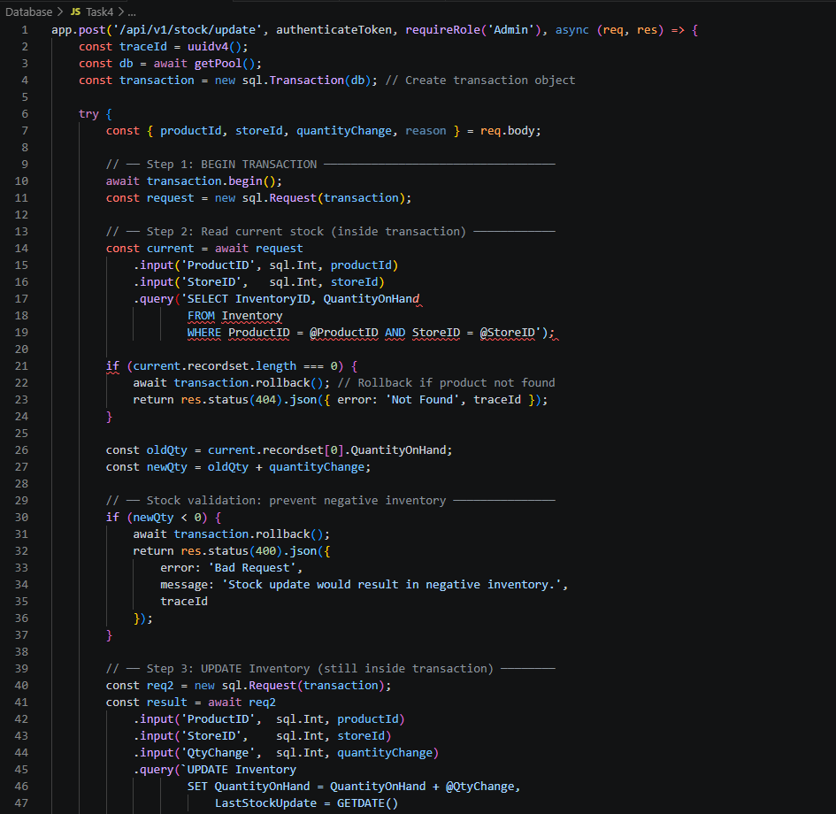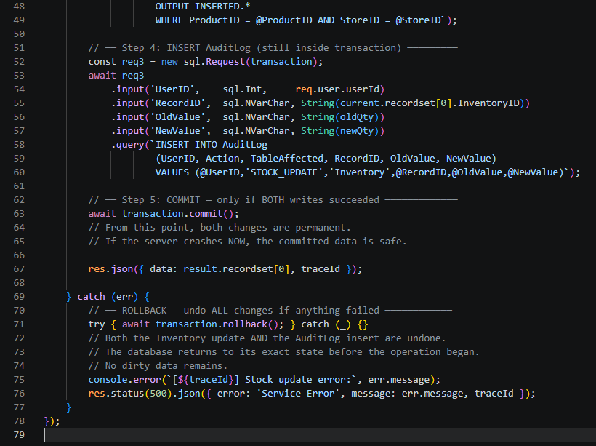

 | Scenario | What Happens with the Transaction Fix
1 | Server crashes before BEGIN TRANSACTION | Nothing has been written. Database is unchanged. No dirty data.
2 | Crash after UPDATE Inventory but before INSERT AuditLog | SQL Server detects the open (uncommitted) transaction and automatically rolls it back on restart. The Inventory change is undone. No dirty data. No orphaned audit gap.
3 | Crash after INSERT AuditLog but before COMMIT | Same as above — uncommitted transaction is rolled back. Both writes are undone. Database returns to pre-operation state.
4 | COMMIT completes, then server crashes | Both changes are already durable on disk. SQL Server recovers the committed state on restart. Data is clean and complete.
5 | Stock update would make QuantityOnHand negative | The new validation check detects this before any write occurs, rolls back the transaction, and returns a clear error message. Inventory is protected.

Summary
The table most likely to suffer from dirty data during a crashed Stock Update is the Inventory table, because its QuantityOnHand column can be committed in isolation without the matching AuditLog entry — leaving the database in an unexplainable intermediate state. The SQL Transaction fix resolves this by making both writes atomic: they succeed together or fail together, with an automatic rollback on any failure. This is a foundational principle of data integrity in any financial or stock management system.

